**Excel Assignment – 7**

1. **Using Insert Function, give examples of any function available in the different dropdowns present in the function library. For example AutoSum, Recently Used, Text, Date & Time, etc.**

**INSERTING A FUNCTION**: There are several ways to insert functions.

Before anything, you need to make sure your cursor is in the cell in which you want the result.

Once there, choose one of the methods below to insert your function:

* On the Home Ribbon, click on the arrow next to the AutoSum icon and select More Functions…
* Go to the Formulas Ribbon – choose either the Insert Function icon to bring up the Insert Function dialog box

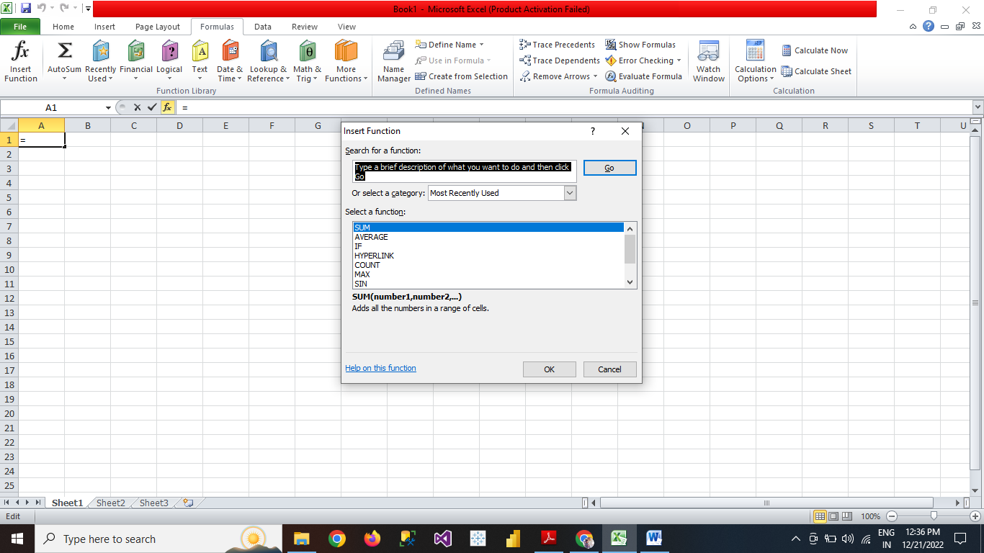

2. **What are the different ways you can select columns and rows?**

Select one or more rows and columns

1. Select the letter at the top to select the entire column. Or click on any cell in the column and then press Ctrl + Space.
2. Select the row number to select the entire row. Or click on any cell in the row and then press Shift + Space.
3. To select non-adjacent rows or columns, hold Ctrl and select the row or column numbers.

* 1. **What is AutoFit and why do we use it?**

Excel's AutoFit feature is designed to automatically resize cells in a worksheet to accommodate different sized data without having to manually change the column width and row height.

**AutoFit Column Width**- changes the column width to hold the largest value in the column.

**AutoFit Row Height** - adjusts the column width to match the largest value in the row. This option expands the row vertically to hold multi-line or extra-tall text.

1. **How can you insert new rows and columns into the existing table?**

Add a row or column

You can add a row above or below the cursor position.

1. Click where you want in your table to add a row or column and then click the **Layout** tab (this is the tab next to the **Table Design**tab on the ribbon).
2. To add rows, click **Insert Above** or **Insert Below** and to add columns, click **Insert Left** or **Insert Right**.

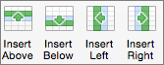

**5. How do you hide and unhide columns in excel?**

* Right-click the selected column or row you want to hide and choose **Hide**.
* se the shortcut **Ctrl + 9** to hide rows and **Ctrl + 0** to hide columns.
* Click the **Home** tab and in the **Cells** group, click **Format** > **Hide and Unhide** and pick either **Hide Rows** or **Hide Columns**.
  1. **Create an appropriate table within the worksheet and use different functions available in the AutoSum command.**

Here are common functions you can execute using the AutoSum Button:

* AVERAGE – This function returns the average (arithmetic mean) of a range of numbers.
* COUNT NUMBERS– This function counts the total number of cells with numbers.
* MAX – This function returns the largest number.
* MIN – This function returns the smallest value.